Experience Brazilian culture through samba music & dance
SAMBA WORKSHOP
The Essence of Samba Workshop Series:
Starts Jan.30th 2011

Sunday Jan 30th, Feb.6th, Feb 13th 3pm-5pm

1 additional class per week required Mondays, Wednesdays or Saturdays

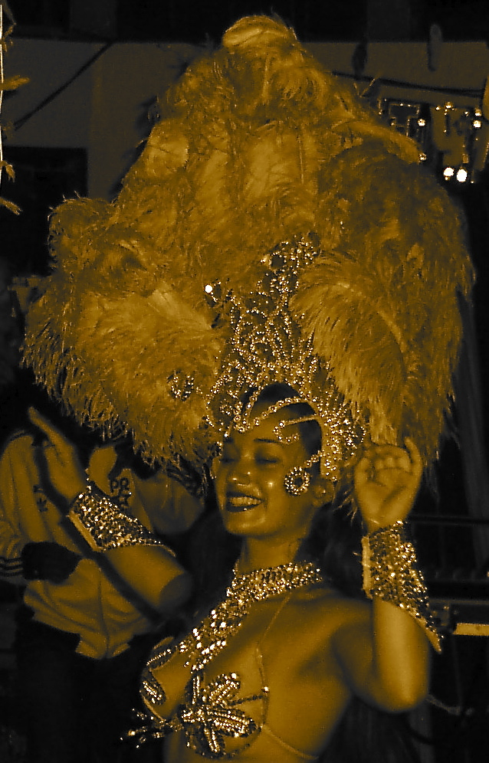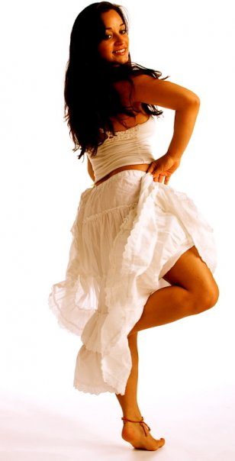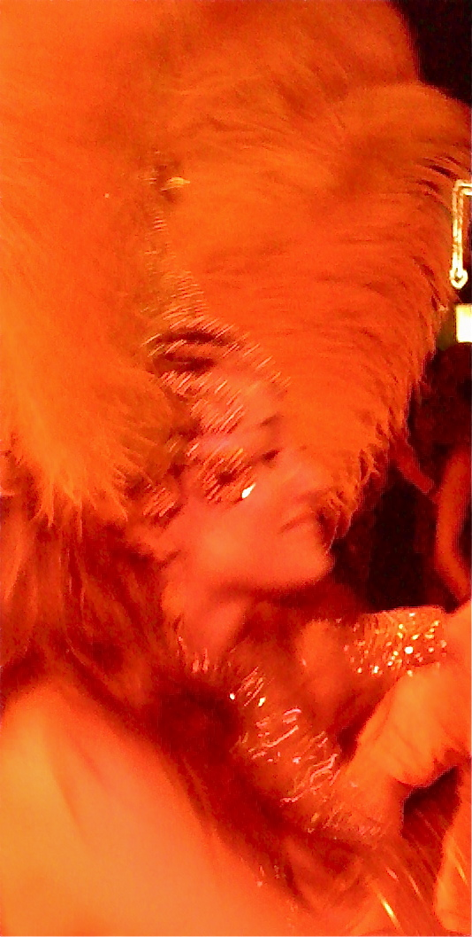

Samba Intensive Workshop Series 3 Sessions $110
Or $45 per workshop

Includes:
Samba Reggae, Samba de Roda, Samba no Pé & Afro-Brazilian Movement Technique Class with Gisella Ferreira
& Music Workshop with Dana Maman

Workshops designed to increase understanding of Samba Music and Dance, while increasing: mind, body & spirit consciousness & promoting healing & healthy living.

WWW.GISELLASAMBISTA.COM

Location: Brasil Brasil Cultural Center
For more info contact Gisella Ferreira at gisellasambista@gmail.com or (831) 229-4147

